Table of Contents

1 Visualization 1 2

1.1 (Why) 4

1.2 (What) 4

1.3 (How) 4

2 Visualization 2 7

2.1 (Why) 7

2.2 (What) 7

2.3 (How) 8

3 Visualization 3 10

3.1 (Why) 10

3.2 (What) 10

3.3 (How) 11

Figure 1: Commonly used aesthetics in data visualization: position, shape, size, colour, line width, line type. 5

Figure 2: Bar chart that illustrates overall performance of students. 6

Figure 3: Scatter plot that displays the relationship between English and Numeracy 9

Figure 4:Line chart that shows the count of each subject. 12

# Visualization 1

## (Why)

1. **Target Audience: An experienced year 5 Class Teacher**

An experienced year 5 class teacher who is well-versed in the curriculum and assessment practices for year 5 students. The experience includes administering, evaluating, and interpreting student assessments in various subjects. The class teacher understands what constitutes different performance levels such as high, average, low, in these categories and is accustomed to interpreting scores and other quantitative data. The purpose of this visualization is to assist the teacher in evaluating the overall performance of their students, thereby guiding potential adjustments in teaching strategies or identifying areas where additional support may be needed.

1. **Visualisation Intent**

To provide a clear and immediate representation of each student's overall performance, categorized into “Excellent," "Average," and "Bad." This will enable the teacher to promptly identify which students fall into each category and to assess the distribution of students across these performance categories. Consequently, the teacher can make informed adjustments to instructional strategies or allocate targeted support where it is most needed.

1. **Assumptions**

* The teacher is familiar with interpreting bar charts and understands the meaning of performance categories.
* The teacher is well-acquainted with the average marks required to classify students into the respective performance categories.

## (What)

1. **Raw Data**

* Student ID: Unique Identifiers for students
* Subject Scores: Marks for Reading, Writing, Spelling, Grammar, and Numeracy.

1. **New Data**

* Overall Performance Score: An average score calculated from the marks in all subjects.
* Performance Category: Classifying each student into "Excellent," "Average," or "Bad" based on their overall

performance score.

1. **Calculations**

* Overall Performance Calculation: (Reading + Writing + Spelling + Grammar + Numeracy) / 5
* Performance Categories: Defined thresholds (e.g., Excellent: >75, Average: 35 - 74, Bad: <35) to categorize students.

1. **Data Limitations**

* Thresholds: Performance categories are subjective and may not apply universally across different educational contexts.
* Equal Weighting: In the data, each subject is given equal weight, which does not reflect the importance or difficulty level of each subject. Some subjects can be more critical for the students' overall learning objectives.

## (How)

1. **Chart**

According to Riaz (Riaz, 2019), bar charts are designed to represent categorical variables and are ideal for counts. Bar charts show and compare frequency, number, or other metrics (e.g. mean) for various data categories. They are easy to interpret. They are effective for visualizing nominal or ordinal categories.

To assess the overall performance of students across different categories, a bar chart is a suitable choice. This involves calculating the mean score for each subject and categorizing the results into ordinal categories such as “Excellent,” “Average,” and “Bad.”

1. **Aesthetics:**

Aesthetics describe every characteristic of a given graphical element as illustrated in the figure below. All graphical elements have a *shape*, a *size*, and a colour*.* Even if we are to draw a black-and-white drawing, graphical elements need to have a colour to be visible, for instance black if the background is white or white if the background is black (Wilke, 2020).

Figure 1: Commonly used aesthetics in data visualization: position, shape, size, colour, line width, line type.

Wilke, C. O. (2020). Fundamentals of Data Visualization. In *clauswilke.com*. https://clauswilke.com/dataviz/aesthetic-mapping.html

### **Colour Coding**

### **Green for "Excellent" Performance**: The colour green, commonly associated with positive outcomes and success, signifies that a student’s performance is excellent. This immediate visual cue allows teachers to easily identify students who are excelling.

### **Yellow for "Average" Performance**: Yellow serves as a neutral colour that stands between the extremes of green and red. This colour effectively communicates that while the performance is acceptable, it does not stand out as exceptional.

### **Red for "Bad" Performance**: Red is used to signal warnings or negative situations. In this data visualization, it indicates that a student’s performance is below expectations and that they require additional support or intervention.

### **Hover Feature**

### This interactive element provides detailed information when users hover over a bar, including the exact performance score and the corresponding performance category. This feature enriches the chart with deeper insights and enhances user engagement.

### **Labels**

### Each bar is clearly labelled with the student ID and performance category. This labelling ensures that the chart is easy to interpret, allowing teachers to quickly associate each bar with the respective student and their performance level.

1. **Insert the Visualisation:**

Figure 2: Bar chart that illustrates overall performance of students.

1. **Review**

The bar chart provides a clear and intuitive representation of each student's overall performance, with the x-axis titled as “Student ID” and y-axis titled as “Overall Performance”. The use of colour coding— green for excellent performance, yellow for average performance, and red for below average performance—allows quick and easy identification of students' performance levels immediately. This visual differentiation helps to immediately distinguish between excellent and poor performers.

The chart features a hover function that reveals detailed information about each student's performance. When hovering over a bar, users can access specific performance scores and the categorized performance level, offering a deeper understanding of each student's academic standing.

Each bar is also labelled with the student ID, which explicitly associates the bar with a specific student. This labelling ensures that teachers can quickly and accurately identify which student’s performance is being represented by each bar.

This combination of colour coding, hover details, and clear labelling makes the bar chart an effective tool for teachers. It facilitates an immediate and comprehensive assessment of individual student performance, allowing the teacher to quickly grasp the overall performance landscape and identify areas for further support or intervention.

1. **Improvements:**

Colour Contrast: Ensure that the colours used for performance categories have sufficient contrast to be distinguishable by individuals with colour vision deficiencies. That is using patterns or textures in addition to colours. This will enhance the accessibility and ensures that the chart is readable by a wider audience.

Summary Section: Including a summary or analysis section below or alongside the bar chart, highlighting key insights or trends observed in the data. This will help viewers quickly grasp the main takeaways and understand the implications of the data.

# Visualization 2

## (Why)

1. **Target Audience: Subject Teachers and Academic Coordinators**

**Subject Teachers:** Teachers who specialize in specific subjects such as Mathematics (Numeracy) or English (Reading, Writing, Spelling and Grammar). They need to understand how their students' performance in their subject correlates with performance in other subjects. They benefit from seeing how well their students' Numeracy performance correlates with their overall English performance, which can help in tailoring instruction and identifying students who needs additional support.

**Academic Coordinators:** Educational administrators responsible for overseeing curriculum effectiveness and student performance across multiple subjects. They utilize such data to identify trends and patterns across the school, evaluate the effectiveness of educational interventions, and make informed decisions on curriculum development.

1. **Visualization Intent**

To uncover the relationship between students’ overall English Performance scores and their Numeracy scores. To reveal any patterns or correlations between students' achievements in Numeracy and their combined English skills, which includes Reading, Writing, Spelling, and Grammar. This will enable the target audience to understand which subjects may need focus to enhance performance in other areas.

1. **Assumptions**

* Understanding of Data Relationships: The target audience is assumed to have a basic understanding of scatter plots and correlation analysis, including how to interpret the direction and strength of relationships between variables.
* Knowledge of Data Interpretation: It is assumed that the audience can interpret the scatter plot to determine whether higher scores in one area are associated with higher scores in another, indicating a positive or negative correlation.

## **(What)**

1. **Raw Data**

* **Student IDs:** Unique identifiers for each student.
* **Numeracy Scores:** Scores representing students’ performance in Numeracy.
* **English Scores:** Individual scores in Reading, Writing, Spelling, and Grammar.

**Note:** To plot the scatter plot, the data for Numeracy scores is used directly, and the English Performance score is calculated from the Reading, Writing, Spelling, and Grammar scores.

1. **New Data**

* **Derived Knowledge:** The English Performance score is computed using the following formula:

English Performance = (Reading + Writing + Spelling + Grammar) / 4

* **Plot Data:** Each data point on the scatter plot represents a student, with their Numeracy score plotted on the X-axis and their calculated English Performance score on the Y-axis.

1. **Calculations**

* Calculation of English Performance:

English Performance = (Reading + Writing + Spelling + Grammar) / 4

* Scatter Plot Data Points: For each student, the Numeracy score is plotted on the X-axis, and the English Performance score is plotted on the Y-axis.

1. **Data Limitations**

* **Scope of Data:** The data is limited to the scores provided and does not account for external factors that might affect student performance, such as personal circumstances or teaching methods.
* **Data Granularity:** The scatter plot assumes that English Performance calculated as an average provides an adequate representation of students' overall English abilities, without considering potential variances in individual subject areas.

## (How)

1. **Chart:**

According to the research (CFI Team, 2022), the primary use of the scatter plot is to show the relationship between two variables and analyse the nature of this relationship. Observed relationships can be positive or negative, linear or non-linear, and may vary in strength from strong to weak.

Therefore, a scatter plot is ideal to use here as it is effective in visualizing the relationship between two continuous variables—Numeracy and English Performance. It helps in understanding whether higher performance in Numeracy correlates with better English performance or vice versa.

1. **Aesthetics:**

**Colour**

A gradient colour scheme is used to represent different ranges of Numeracy scores. The gradient ranges from red for the lowest scores to green for the highest scores. This colour coding helps the target audience quickly distinguish between different performance levels, making it easier to assess the relative Numeracy performance of each student immediately.

**Size**

The size of each scatter plot marker differs according to the English Performance score. Larger circles illustrate lower English Performance scores, while smaller circles represent higher English Performance scores. This sizing aesthetic enables for an immediate visual cue regarding each student's performance in English, adding another layer of information to the scatter plot.

**Labels**

Each data point on the scatter plot is labelled with the student ID. This feature ensures that each student’s performance is easily identifiable, allowing target audience to connect the visual data points with specific individuals for a more detailed analysis.

**Hover Feature**

The hover feature enriches the scatter plot by displaying additional details when a user hovers over a data point. It displays the student ID, Numeracy score, and English Performance score. This interactivity provides a deeper insight into each student’s performance.

**Position**

The scatter plot’s positions data points based on performance levels. Students who perform well in both Numeracy and English are located towards the right side of the plot, illustrating higher scores in English and Numeracy. Conversely, students with lower scores in both subjects are positioned towards the left side. Those with average scores are drawn in the middle of the plot. This spatial arrangement visually communicates performance trends, allowing target audience to easily identify high performers, average performers, and those needing additional support.

1. **Insert the Visualization:**

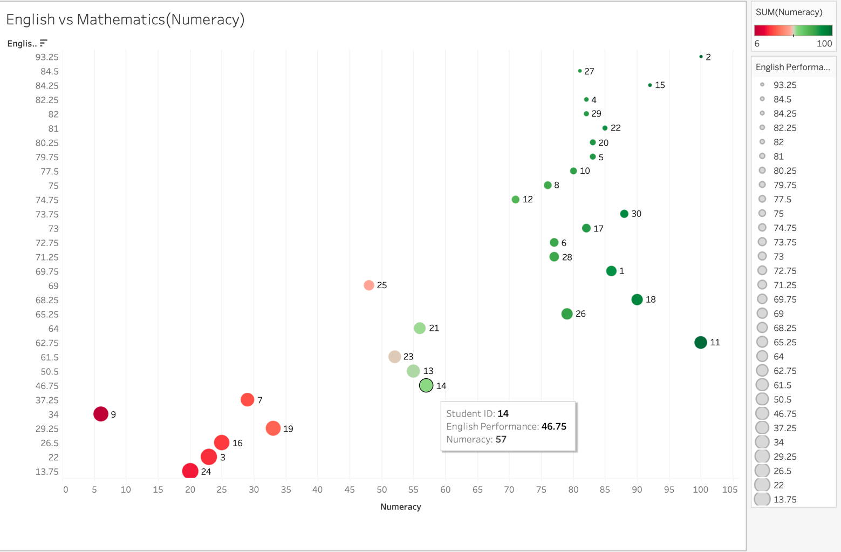

Figure 3: Scatter plot that displays the relationship between English and Numeracy

1. **Review**

The scatter plot effectively illustrates the relationship between English Performance (X-axis) and Numeracy (Y-axis). This visualization allows target audience to visually evaluate the correlation between students' performance in these two critical areas. By plotting English Performance against Numeracy scores, the scatter plot reveals important patterns, trends, and outliers.

The scatter plot displays a general trend where students who perform well in English (scoring above 60) tend to achieve high scores in Numeracy as well, typically over 70. This shows a positive correlation where strong performance in English is associated with higher Numeracy scores.

Students with scores below 40 in English generally struggle with Numeracy as well, with their scores often failing to exceed 35. This represents a need for targeted support, as low English scores are frequently accompanied by poor performance in Numeracy.

Students with English scores between 50 and 60, usually have Numeracy scores in the range of 50 to 60. This trend depicts that moderate performance in English is associated with similar levels of Numeracy achievement.

There are three students whose scores are 60s in English but did not achieve comparable performance in Numeracy, with scores falling below 60. This deviation from the general trend reveals that while these students perform adequately in English, they face specific Numeracy challenges in Numeracy that are not immediately apparent from their English performance alone. These outliers may benefit from additional investigation to understand the underlying factors affecting their performance in Numeracy despite their strengths in English.

1. **Improvements:**

**Add Trend Line:** Use of a trend line to visually represent the overall direction of the correlation between Numeracy and English Performance.

# Visualization 3

## (Why)

1. **Target Audience: Curriculum Planners**

These individuals are responsible for evaluating student performance to make decisions about curriculum program, resource allocation, and targeted interventions. They need insights into which subjects students excel in to identify strengths and weaknesses in the current educational program.

1. **Visualisation Intent**

The line chart displays the number of students who scored more than 35 in each subject. This helps curriculum planners quickly identify which subjects have a higher number of passing students, and which subjects may need additional support. The visualization assists in understanding where students are performing well and where intervention may be necessary.

1. **Assumptions**

* **Passing Threshold:** The audience understands that scoring above 35 is used as a benchmark for identifying students who are passing in each subject. This benchmark is crucial for evaluating subject-specific performance and determining areas requiring additional focus.
* **Comparative Analysis:** The audience will compare performance across subjects to determine where students are generally excelling or struggling based on the passing mark.

## (What)

1. **Raw Data**

* The individual student scores across five subjects: Reading, Writing, Spelling, Grammar, and Numeracy.

1. **New Data**

* **Count of Passing Students**: The new data required is the students count who scored more than 35 in each subject. This involves aggregating the raw scores to show how many students meet or exceed this new performance threshold for each subject.

1. **Calculations:**

* **Count Calculation**

**SUM(IF [Reading]>35 THEN 1 ELSE 0 END)**

This formula calculates the number of students who scored more than 35 in Reading. Similar calculations are performed for Writing, Spelling, Grammar, and Numeracy. This method generates a count of students exceeding the score of 35 for each subject.

1. **Data Limitations**

* **Binary Threshold:** Using a threshold of 35 means the chart does not capture how well students perform beyond this mark. The chart does not differentiate between scores just above 35 and those significantly higher.

## (How)

1. **Chart**

According to Cisneros (2020), line graphs (or line charts) are most effective for illustrating changes in values over time or for comparing how multiple variables changes over time in relation to each other. Besides, when there are smaller changes, it is better to use line charts rather than the bar charts.

Therefore, the line chart is effective for showing the number of students who passed each subject. Each line represents the count of students scoring above 35 in a particular subject, allowing for clear comparison of performance across subjects.

1. **Aesthetics:**

**Colour**

Each subject is represented by a unique colour to facilitate easy differentiation. For instance, Reading, Writing, Spelling, Grammar, and Numeracy are each assigned a distinct colour, ensuring that viewers can quickly identify which line corresponds to which subject. Darker shades are used to represent higher counts of students scoring above 35, while lighter shades indicate lower counts. This gradient colour scheme helps viewers intuitively understand the relative performance levels immediately.

.

**Markers**

Markers are placed on the lines to denote exact counts of students for each subject. These markers provide precise data points, making it easier to compare the number of students performing above the threshold across different subjects.

**Lines**

Solid lines are used for clarity and simplicity, ensuring that the focus remains on the data trends without visual distractions.

**Labels**

Each line is clearly labelled with the subject it represents. This labelling is crucial for understanding which line corresponds to which subject.

**Hover Feature**

A hover feature displays additional details when hovering over a data point. This feature reveals the exact count of students for each subject, enhancing the chart’s usability and providing deeper insights into the data.

1. **Insert the Visualisation:**

Figure 4:Line chart that shows the count of each subject.

1. **Review**

The line chart effectively illustrates the number of students who scored above 35 in each subject, providing a clear picture of student performance relative to the new passing mark. This visualization enables curriculum planners to swiftly identify which subjects are showing higher or lower pass rates.

The chart demonstrates that many students, with counts nearing 26 and 27, have performed well in Reading and Spelling. Conversely, Writing shows the lowest count, with only 20 students surpassing the passing mark. This discrepancy highlights areas where students are struggling and informs that Writing may need additional support or targeted interventions. Overall, the chart serves as a valuable tool for evaluating subject-specific performance and guiding educational plans.

1. **Improvements**

**Percentage Representation:** Utilizing a percentage information alongside counts to show the proportion of students performing above 35 in each subject. This helps in understanding relative performance.

**References**

CFI Team. (2022, December 18). *Scatter Plot*. Corporate Finance Institute.

<https://corporatefinanceinstitute.com/resources/data-science/scatter-plot/>

Cisneros, M. (2020, March 24). *what is a line graph, how does a line graph work, and what is the best way to use a line graph?* Storytelling with Data. <https://www.storytellingwithdata.com/blog/2020/3/24/what-is-a-line-graph>

Riaz, S. (2019, September 22). *Report Research Data Using Box Plots and Bar Charts*. Enago Academy. <https://www.enago.com/academy/report-research-data-using-box-plots-and-bar-charts/>

Wilke, C. O. (2020). Fundamentals of Data Visualization. In *clauswilke.com*. <https://clauswilke.com/dataviz/aesthetic-mapping.html>